E-commerce Application on IBM Cloud Foundry

Phase 5: Project Documentation & Submission

Objective:

* The objective our fashion e-commerce application is to create a comprehensive and sustainable platform that supports artisans and their products while delivering a personalized shopping experience for customers. This objective encompasses empowering artisans, ensuring product quality, promoting global accessibility, personalization, community building, sustainability, mobile accessibility, continuous improvement, marketing, revenue generation, data security, and measurable impact. The platform seeks to revitalize sustainable practices, and establish itself as a trusted marketplace for unique, artisanal items, benefitting both creators and customers.

Phase 1:

Problem Definition:

In today’s era of technology, the global marketplace is going through changes. Both consumers and artisans face challenges when it comes to buying and selling products. These challenges encompass.

1. Limited Reach: To a Global Market often located in underserved areas find it difficult to connect with an audience for their exquisite handcrafted goods.

2. E commerce Development: Creating a user-friendly e commerce platform from scratch can be intricate time consuming and expensive for artisans and small businesses. This hampers their ability to compete effectively in the expanding realm of commerce.

3. Ensuring Payment and Transaction Security: The utmost concern, for both buyers and sellers is guaranteeing payment processing while safeguarding customer information. Building a foolproof payment system can present challenges.

4.User Experience: Today’s consumers have come to anticipate a user-friendly shopping experience. Unfortunately, numerous e commerce platforms currently available either lack the features. Have convoluted checkout processes that can be off putting.

5.Marketing and Promotion: Beyond the hassle of setting up a shop, it's tough for artisans to get their work seen in the first place. Standing out in a crowded online marketplace takes serious marketing. These talented folks need a way to get their products in front of the right audiences. Otherwise, they're just one more needle in an endless digital haystack. These are some of the obstacles faced by individuals involved in the handmade products industry amidst our advancing world.

Our Solution:

To provide an e-commerce platform, built on the IBM Cloud Foundry framework aims to tackle these hurdles by providing a secure and user-friendly solution. It offers artisans the opportunity to Showcase their handcrafted products, to an audience. Access an intuitive and ready to use e-commerce infrastructure that is easy to navigate. Ensure secure payment processing and safeguarding of customer data. Provide customers with an enjoyable and straightforward shopping experience. Reduce the technical complexities and resource demands of managing an online store. Comply with data protection regulations for added security measures. Utilize marketing tools and features to promote their products effectively. By addressing these challenges head on the e commerce application, on IBM Cloud Foundry empowers artisans and small businesses to thrive in the marketplace while connecting with a customer base. Design thinking:

1. Platform Design:

The platform aims to solve several challenges, including limited market access, complex e-commerce development, payment security, and user experience issues. Key components of the platform include user friendly design, product listings, a shopping cart and checkout process, secure payment options, user profiles, reviews and ratings, marketing tools, analytics, data privacy compliance, customer support, and continuous improvement. The platform's goal is to provide a seamless and secure shopping experience for both artisans and customers while promoting handmade products worldwide.

2. Product Showcase:

The product showcase is a central element of the artisanal e-commerce platform. It serves as the digital storefront where skilled artisans can display their handmade products to a global audience. Key features for product showcase we include in our application are high-quality product imagery, detailed descriptions, transparent pricing, category organization, artisan profiles, robust search and filtering options, product recommendations, user reviews and ratings, featured product highlights, responsive design, fast load times, SEO optimization, inventory management tools, security measures, and customer feedback mechanisms. The product showcase aims to create an engaging and informative shopping experience, fostering a connection between artisans and customers while facilitating the discovery and purchase of unique handmade items.

3.User Authentication:

User authentication is the process of verifying the identity of individuals or entities seeking access to digital resources. We implement user authentication with robust password protection and consider optional multi-factor authentication for added security. Provide password recovery options and enable users to manage their profiles and permissions through role-based access control. Prioritize security measures, including encryption and regular updates, while ensuring compliance with data protection regulations. Thorough testing, monitoring, and user support are essential components of a successful user authentication implementation, enhancing the overall user experience and platform security.

4. Shopping Cart and Checkout:

We going to provide shopping cart that allow users to easily add, view, edit, and remove products while displaying pertinent details. The checkout process should streamlined, collecting necessary information such as shipping and billing details, and integrating with secure payment gateways. We provide Features like real-time shipping quotes, order confirmation, inventory management, error handling, and security measures are essential components. We will do regular testing and optimization, along with mobile responsiveness to ensure a seamless user experience, ultimately boosting successful transactions and customer satisfaction

5. Payment Integration:

Process involves selecting a reputable payment gateway, setting up a merchant account, and integrating the payment gateway's API into your platform. It's crucial to prioritize security by encrypting payment data, complying with PCI DSS standards, and implementing error handling for failed transactions. We Offer various payment methods, support multiple currencies, and optimize the payment flow for a user-friendly experience. Regular testing, mobile responsiveness, and clear customer communication.So that we can ensure a successful and compliant payment integration that enhances the overall shopping experience for your customers.

6. User Experience:

We prioritize intuitive navigation, responsive design, and fast loading speeds to enhance accessibility across devices. Implement effective search functionality, clear product presentations, and a streamlined checkout process for user convenience. We also ensure secure payment handling, personalize content, and provide customer support with transparent policies. Enable mobile payments, monitor performance, and maintain accessibility standards while regularly updating the application based on user feedback and A/B testing to optimize the overall shopping experience, fostering customer loyalty and brand reputation.

Phase 2: Innovation

1. Product Reviews:

• User-Generated Reviews: Allow customers to leave reviews and ratings for products they've purchased. Encourage honest feedback to build trust.

• Moderation: Implement a moderation system to prevent spam, fake reviews, or inappropriate content.

• Display Reviews: Display product reviews prominently on product pages to help potential buyers make informed decisions.

• Sort and Filter: Allow users to sort and filter product reviews by criteria such as date, rating, and helpfulness.

• Review Notifications: Notify customers when their reviews are approved and published to encourage engagement.

2. Wishlists:

• User Accounts: Require users to create accounts or log in to save items to their wishlist. This can also help with personalization.

• Add to Wishlist Button: Include an "Add to Wishlist" button on product pages to make it easy for users to save products they're interested in.

• Wishlist Management: Allow users to view, edit, and organize their wishlists. They should also be able to remove items.

• Sharing: Enable users to share their wishlists with friends and family, especially useful for special occasions.

• Reminder Notifications: Send occasional reminder notifications to users about items in their wishlist, especially if there are price drops or limited stock. 3. Personalized Recommendations:

• User Profiling: Collect user data and preferences through their interactions with the platform, such as search history, purchase history, and wishlist items.

• Machine Learning Algorithms: Implement recommendation algorithms that analyze user behavior and preferences to suggest relevant products.

• Recommendation Widgets: Display personalized product recommendations on the homepage, product pages, and in emails.

* Segmentation: Segment users based on their preferences and behavior, and tailor recommendations accordingly (e.g., "Recently Viewed," "Recommended for You").

4. User Engagement:

• Email Notifications: Send personalized email notifications to users based on their activity, such as abandoned cart reminders, product updates, and promotions.

• User Activity Feed: Implement an activity feed that shows users what products have been recently added, liked, or purchased by other users.

• Social Sharing: Enable users to share their purchases and favorite products on social media, increasing engagement and potentially attracting new users.

5. Analytics and Optimization:

• Monitor User Interaction: Use analytics tools to track how users engage with these features and gather insights on their effectiveness.

• A/B Testing: Continuously test variations of these features to optimize their performance and user satisfaction.

6. Privacy and Data Protection:

• Data Security: Ensure that user data collected for personalized recommendations is protected and compliant with data protection regulations.

• Transparency: Clearly communicate to users how their data is being used to provide personalized experiences and provide opt-out options if desired.

Phase 3 – Development Overview :

Your Attire is not just another e-commerce website for clothing; it's a style revolution waiting to happen. We've reimagined the online shopping experience to create a platform that's unique, engaging, and, most importantly, all about you. Your Attire is more like a personal fashion hub. It focuses on promoting and showcasing the work of various brands around the world, offering features like product listings, user profiles, robust search and discovery tools, shopping cart and checkout functionality, customer reviews and ratings, customer support, marketing and promotions, community and social features, mobile-friendliness, secure transactions, analytics and reporting, and integration with shipping and logistics services. This application celebrates creativity while connecting fashion lovers with a broader customer base, making it easier for retailers to sell their unique products and for customers to find and purchase high-quality, durable goods.

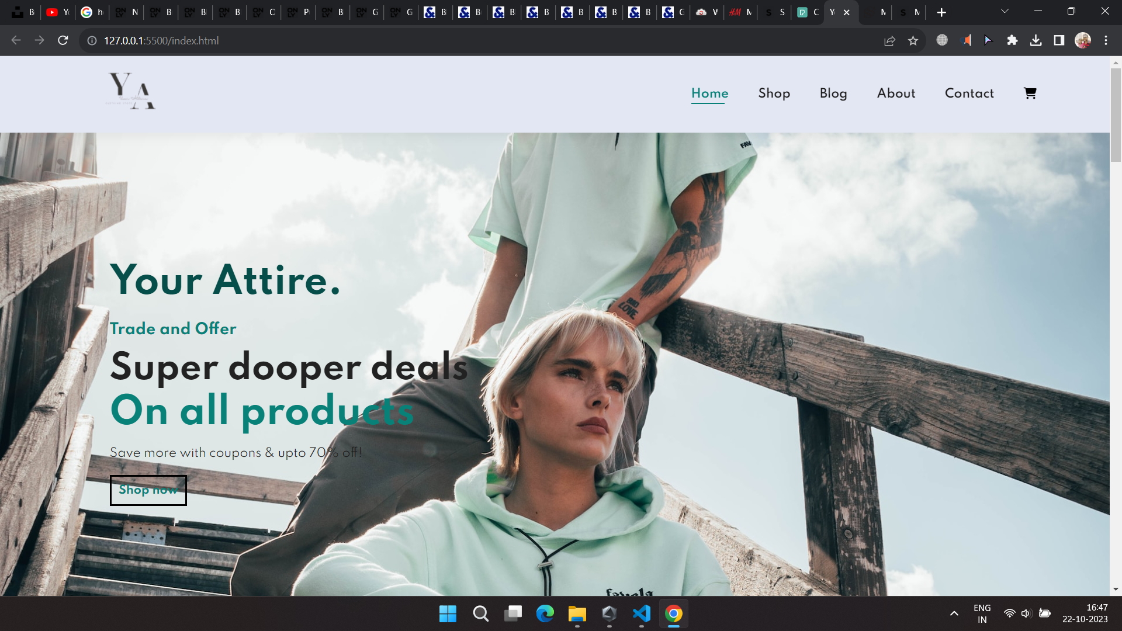

Phase 4: Development Part 2

We Continue building the e-commerce platform by implementing user authentication, shopping cart, and checkout functionality and we have successfully Implemented user registration and authentication features using a backend server (e.g., Node.js, Python) and Implemented shopping cart functionality, calculate the total, and enable a smooth checkout process.

Connecting an e-commerce website with MongoDB involves planning, database setup, backend and frontend development, testing, deployment, security, performance optimization, monitoring, and ongoing maintenance. MongoDB's flexibility is ideal for handling product data in an e-commerce context.

User authentication, order processing, payment integration, and user-friendly design are key components of such a website. It's essential to ensure security, optimize performance, and be prepared to scale as the website grows.

Sign up Page:

• The signup page at Aura Traffic is where you embark on your journey to becoming a valued member of our artisan community. As a new member, you'll unlock exclusive benefits and enjoy a personalized experience, complete with tailored product recommendations and special offers.

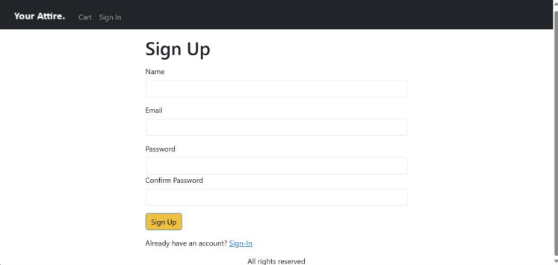

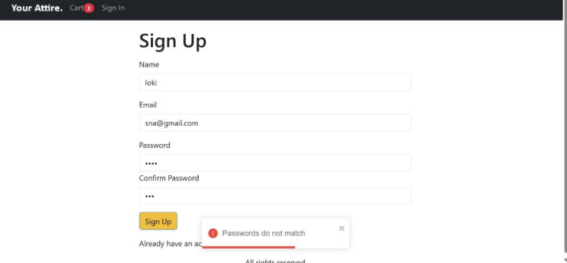

Home Page :

Welcome to **Your Attire**! We are a premier online destination for all your fashion needs. Our mission is to provide you with the latest trends and styles right at your fingertips. We offer a wide range of clothing options, from casual wear to formal attire, ensuring that you find exactly what you’re looking for. Our collection is carefully curated to include high-quality pieces that are both stylish and comfortable. With our user-friendly interface and secure payment options, shopping for your perfect outfit has never been easier. So why wait? Dive into our fashion-forward world and let **Your Attire** redefine your style statement. Happy shopping!



Product Page:

* A product page on an e-commerce website serves as the hub for showcasing and providing details about a specific product. It typically includes product name, images, description, price, availability, and options for customers to add the product to their shopping cart. Additional features may encompass user reviews, related products, shipping and returns information, social sharing, Q&A, and more. A well-designed product page is essential for informing and persuading customers while offering a smooth and secure shopping experience.

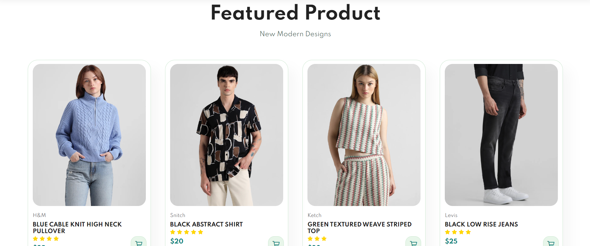



Cart:

The shopping cart page is where you can review and manage the items you have selected to purchase from our website. You can easily add or remove items, change the quantities, and see the product details. You can also view the sum total of your order, including the taxes and shipping fees, and apply any promo codes or discounts you may have. When you are ready to proceed, you can click on the checkout button to enter your payment and shipping information. Our shopping cart page is designed to offer you a convenient and secure shopping experience.



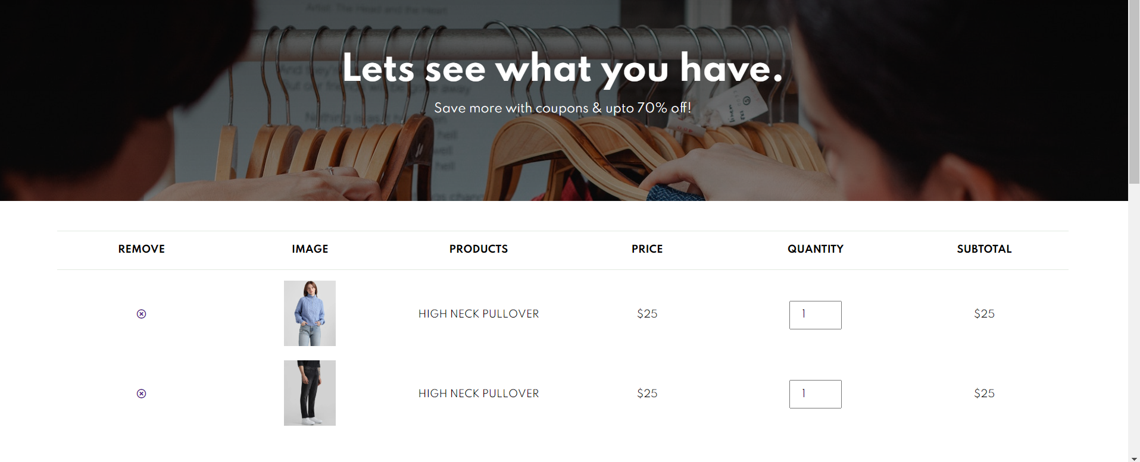

Payment Page:

• A payment page is a crucial part of the e-commerce checkout process where users enter their payment information to finalize their purchases. It involves offering various secure payment methods, presenting a payment form, verifying billing information, and displaying the total amount and order summary. The page must prioritize security, compliance with data protection standards, and reliable real-time payment processing. Offering guest checkout and account creation options, ensuring responsive design, optimizing the user experience, and utilizing analytics and A/B testing are vital for a successful payment page.

• Secure Payment Gateway: Security is paramount in payment processing. To protect users' sensitive data, the payment page must utilize secure and encrypted channels for transmitting payment information. Payment gateways, like Stripe or PayPal, play a crucial role in ensuring the security of transactions. • Billing Information: Verifying that the billing information matches the user's payment method is a standard practice for added security and to prevent fraud.

